实验报告
姓名：张立成 学号：10165102104 班级：16级计科
实验题目： 实现2D几何变换 实验时间：2019.10.20

问题描述
对绘制的图形进行平移、旋转和缩放变换，图形包括线段、圆和多边形

求解思路
2D几何变换实际上就是对于图形的各点做相应的处理，主要是矩阵变换。平移最为简单，即是对于原图形的各点增加一个坐标偏移(dx, dy)；旋转和缩放则是对于原图形的各点坐标做一个矩阵变换得到新坐标。

程序代码
平移代码：
def translation(self):
offset_x = self.inputTranslationX.text()
offset_x = float(offset_x) if offset_x else 0
offset_y = self.inputTranslationY.text()
offset_y = float(offset_y) if offset_y else 0
# 图形是圆
if self.center_flag:
self.center_x = int(self.center_x + offset_x)
self.center_y = int(self.center_y + offset_y)
self.midPointDrawCircle()
self.center_flag = False
# 图形是线段或多边形
else:
self.vertexes = [(int(x + offset_x), int(y + offset_y)) for x, y in self.vertexes]
self.joinVertexes()
self.inputTranslationX.setText("")
self.inputTranslationY.setText("")

旋转代码：
def rotation(self):
angle = float(self.inputRotation.text()) if self.inputRotation.text() else 0
angle = angle / 180 * math.pi
sin = math.sin(angle)
cos = math.cos(angle)
rotateMatrix = np.matrix([[cos, -sin], [sin, cos]])
if self.center_flag:
rotated_xy = (rotateMatrix * np.matrix((self.center_x, self.center_y)).T).T.tolist()[0]
self.center_x = int(rotated_xy[0])
self.center_y = int(rotated_xy[1])
self.midPointDrawCircle()
self.center_flag = False
# 图形是线段或多边形
else:
self.vertexes = [(rotateMatrix * np.matrix(xy).T).T.tolist()[0] for xy in self.vertexes]
self.vertexes = [(int(x), int(y)) for x, y in self.vertexes]
self.joinVertexes()
self.inputRotation.setText("")

缩放代码：
def scaling(self):
scale_x = self.inputScalingX.text()
scale_x = float(scale_x) if scale_x else 0
scale_y = self.inputScalingY.text()
scale_y = float(scale_y) if scale_y else 0
scaleMatrix = np.matrix([[scale_x, 0], [0, scale_y]])
# 图形是圆
if self.center_flag:
if scale_x != scale_y:
return
scaled_xy = (scaleMatrix * np.matrix((self.center_x, self.center_y)).T).T.tolist()[0]
self.center_x = int(scaled_xy[0])
self.center_y = int(scaled_xy[1])
self.radius *= scale_x
self.midPointDrawCircle()
self.center_flag = False
# 图形是线段或多边形
else:
self.vertexes = [(scaleMatrix * np.matrix(xy).T).T.tolist()[0] for xy in self.vertexes]
self.vertexes = [(int(x), int(y)) for x, y in self.vertexes]
self.joinVertexes()
self.inputScalingX.setText("")
self.inputScalingY.setText("")

全部代码：
import math
import sys
import numpy as np

from PyQt5 import QtCore, QtWidgets
from PyQt5.QtWidgets import (QApplication, QWidget)
from PyQt5.QtGui import (QPainter, QPen, QPixmap)
from PyQt5.QtCore import Qt

class Edge:
def __init__(self):
self.x = None # 与扫描线相交的点的x坐标
self.dx = None # 斜率的倒数
self.y_max = None # 上端点的y坐标
self.next = None # 指向下一条边

class Transformation(QWidget):

def __init__(self):
super(Transformation, self).__init__()
self.resize(800, 600)
self.board = QPixmap(800, 600)
self.board.fill(Qt.white)
# setMouseTracking设置为False，否则不按下鼠标时也会跟踪鼠标事件
self.setMouseTracking(False)
self.painter = QPainter()
"""
圆形
"""
# 设置起点和终点，并设置标志位以控制打点
self.radius = 0
self.center_x = 0
self.center_y = 0
self.center_flag = False
self.xr = 0
self.yr = 0
"""
线段和多边形
"""
# 设置起点和终点，并设置标志位以控制打点
self.vertexes = []
self.ET = [] # 类似于一个以扫描线y坐标为索引的哈希表
self.AET = None
"""
UI控件
"""
self.inputTranslationX = QtWidgets.QLineEdit(self)
self.inputTranslationX.setText("")
self.inputTranslationX.setGeometry(QtCore.QRect(700, 150, 50, 30))
self.inputTranslationX.setStyleSheet("border-radius:10px;\n"
"background-color:#4C88F7;\n"
"color:#FFF;")
self.inputTranslationY = QtWidgets.QLineEdit(self)
self.inputTranslationY.setText("")
self.inputTranslationY.setGeometry(QtCore.QRect(700, 200, 50, 30))
self.inputTranslationY.setStyleSheet("border-radius:10px;\n"
"background-color:#4C88F7;\n"
"color:#FFF;")
self.translationButton = QtWidgets.QPushButton(self)
self.translationButton.setGeometry(QtCore.QRect(755, 200, 40, 30))
self.translationButton.setText("平移")
self.translationButton.setStyleSheet("border-radius:10px;\n"
"background-color:#4C88F7;\n"
"color:#FFF;")
self.translationButton.setObjectName("translationButton")
self.translationButton.clicked.connect(self.translation)

self.inputRotation = QtWidgets.QLineEdit(self)
self.inputRotation.setText("")
self.inputRotation.setGeometry(QtCore.QRect(700, 270, 50, 30))
self.inputRotation.setStyleSheet("border-radius:10px;\n"
"background-color:#4C88F7;\n"
"color:#FFF;")
self.rotationButton = QtWidgets.QPushButton(self)
self.rotationButton.setGeometry(QtCore.QRect(755, 270, 40, 30))
self.rotationButton.setText("旋转")
self.rotationButton.setStyleSheet("border-radius:10px;\n"
"background-color:#4C88F7;\n"
"color:#FFF;")
self.rotationButton.clicked.connect(self.rotation)

self.inputScalingX = QtWidgets.QLineEdit(self)
self.inputScalingX.setText("")
self.inputScalingX.setGeometry(QtCore.QRect(700, 350, 50, 30))
self.inputScalingX.setStyleSheet("border-radius:10px;\n"
"background-color:#4C88F7;\n"
"color:#FFF;")
self.inputScalingY = QtWidgets.QLineEdit(self)
self.inputScalingY.setText("")
self.inputScalingY.setGeometry(QtCore.QRect(700, 400, 50, 30))
self.inputScalingY.setStyleSheet("border-radius:10px;\n"
"background-color:#4C88F7;\n"
"color:#FFF;")
self.scalingButton = QtWidgets.QPushButton(self)
self.scalingButton.setGeometry(QtCore.QRect(755, 400, 40, 30))
self.scalingButton.setText("缩放")
self.scalingButton.setStyleSheet("border-radius:10px;\n"
"background-color:#4C88F7;\n"
"color:#FFF;")
self.scalingButton.clicked.connect(self.scaling)

def paintEvent(self, paintEvent):
self.painter.begin(self)
self.painter.drawPixmap(0, 0, self.board)
self.painter.end()

def paintPoints(self, x, y):
self.paintPoint(self.center_x + x, self.center_y + y)
self.paintPoint(self.center_x - x, self.center_y + y)
self.paintPoint(self.center_x + x, self.center_y - y)
self.paintPoint(self.center_x - x, self.center_y - y)
self.paintPoint(self.center_x + y, self.center_y + x)
self.paintPoint(self.center_x - y, self.center_y + x)
self.paintPoint(self.center_x + y, self.center_y - x)
self.paintPoint(self.center_x - y, self.center_y - x)

def paintPoint(self, x, y):
self.painter.begin(self.board)
self.painter.setPen(QPen(Qt.black, 6))
self.painter.drawPoint(x, y)
self.painter.end()
self.update()

# 支持线段两点连接以及多边形连接
def joinVertexes(self):
if len(self.vertexes) == 0:
return
# 依次连接各点
for i in range(len(self.vertexes) - 1):
self.BresenhamDrawLine(self.vertexes[i][0], self.vertexes[i][1], self.vertexes[i + 1][0], self.vertexes[i + 1][1])
# 连接第一个点和最后一个点
self.BresenhamDrawLine(self.vertexes[0][0], self.vertexes[0][1], self.vertexes[-1][0], self.vertexes[-1][1])

def mousePressEvent(self, event):
x = event.pos().x()
y = event.pos().y()
if event.buttons() == QtCore.Qt.LeftButton: # 左键按下表示画的点是为了画出线段
self.vertexes.append((x, y))
self.paintPoint(x, y)
elif event.buttons() == QtCore.Qt.RightButton: # 右键按下画出圆形
if not self.center_flag:
self.center_x = x
self.center_y = y
self.center_flag = True
else:
self.xr = x
self.yr = y
self.radius = math.sqrt((self.xr - self.center_x) ** 2 + (self.yr - self.center_y) ** 2)
self.midPointDrawCircle()
else: # 如果点击的不是左键或右键，则连接各顶点构成多边形或线段（一般使用中键MidButton）
self.joinVertexes()

def mouseDoubleClickEvent(self, event):
self.board.fill(Qt.white)
self.update()
# 回到初始状态
self.vertexes.clear()
self.center_x = 0
self.center_y = 0
self.radius = 0
self.center_flag = False
self.xr = 0
self.yr = 0

def BresenhamDrawLine(self, x0, y0, x1, y1):
dx = abs(x1 - x0)
dy = abs(y1 - y0)
x = x0
y = y0
# 通过两点的位置关系和斜率区分不同情况
if x1 > x0:
step_x = 1
else:
step_x = -1
if y1 > y0:
step_y = 1
else:
step_y = -1
if dy > dx:
# 斜率绝对值大于1，交换dx, dy再代入公式，并记录交换的标志位
tmp = dx
dx = dy
dy = tmp
flag_change = True
else:
flag_change = False

delta = 2 * dy - dx
for i in range(1, dx + 1):
# 调用封装好的画点函数画点
self.paintPoint(x, y)
if delta >= 0:
if flag_change:
x += step_x
else:
y += step_y
delta -= 2 * dx
if flag_change:
y += step_y
else:
x += step_x
delta += 2 * dy

def midPointDrawCircle(self):
x = 0
y = self.radius
delta = 1 - self.radius
self.paintPoints(x, y)
while x < y:
if delta < 0:
delta += (2 * x + 3)
else:
delta += (2 * (x - y) + 5)
y -= 1
x += 1
self.paintPoints(x, y)

# 平移
def translation(self):
offset_x = self.inputTranslationX.text()
offset_x = float(offset_x) if offset_x else 0
offset_y = self.inputTranslationY.text()
offset_y = float(offset_y) if offset_y else 0
# 图形是圆
if self.center_flag:
self.center_x = int(self.center_x + offset_x)
self.center_y = int(self.center_y + offset_y)
self.midPointDrawCircle()
self.center_flag = False
# 图形是线段或多边形
else:
self.vertexes = [(int(x + offset_x), int(y + offset_y)) for x, y in self.vertexes]
self.joinVertexes()
self.inputTranslationX.setText("")
self.inputTranslationY.setText("")

# 旋转
def rotation(self):
angle = float(self.inputRotation.text()) if self.inputRotation.text() else 0
angle = angle / 180 * math.pi
sin = math.sin(angle)
cos = math.cos(angle)
rotateMatrix = np.matrix([[cos, -sin], [sin, cos]])
if self.center_flag:
rotated_xy = (rotateMatrix * np.matrix((self.center_x, self.center_y)).T).T.tolist()[0]
self.center_x = int(rotated_xy[0])
self.center_y = int(rotated_xy[1])
self.midPointDrawCircle()
self.center_flag = False
# 图形是线段或多边形
else:
self.vertexes = [(rotateMatrix * np.matrix(xy).T).T.tolist()[0] for xy in self.vertexes]
self.vertexes = [(int(x), int(y)) for x, y in self.vertexes]
self.joinVertexes()
self.inputRotation.setText("")

# 缩放
def scaling(self):
scale_x = self.inputScalingX.text()
scale_x = float(scale_x) if scale_x else 0
scale_y = self.inputScalingY.text()
scale_y = float(scale_y) if scale_y else 0
scaleMatrix = np.matrix([[scale_x, 0], [0, scale_y]])
# 图形是圆
if self.center_flag:
if scale_x != scale_y:
return
scaled_xy = (scaleMatrix * np.matrix((self.center_x, self.center_y)).T).T.tolist()[0]
self.center_x = int(scaled_xy[0])
self.center_y = int(scaled_xy[1])
self.radius *= scale_x
self.midPointDrawCircle()
self.center_flag = False
# 图形是线段或多边形
else:
self.vertexes = [(scaleMatrix * np.matrix(xy).T).T.tolist()[0] for xy in self.vertexes]
self.vertexes = [(int(x), int(y)) for x, y in self.vertexes]
self.joinVertexes()
self.inputScalingX.setText("")
self.inputScalingY.setText("")

if __name__ == "__main__":
app = QApplication(sys.argv)
transform_pyqt = Transformation()
transform_pyqt.show()
app.exec_()

实验结果
界面展示
整个界面都为画板，右侧部分是具体图形变换的参数设置输入框
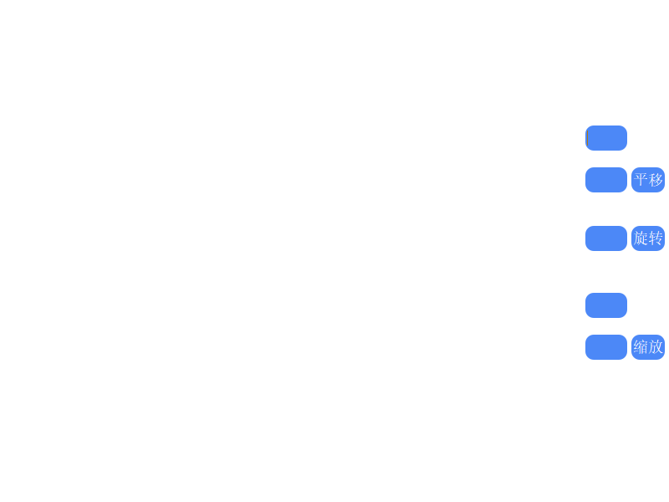
- 平移
- 线段
在画板上点两个点然后点击中键连接
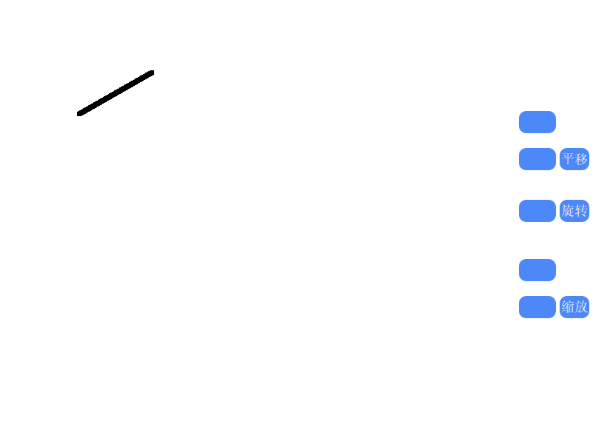
在右侧的两个平移的输入框中分别输入x、y偏移量
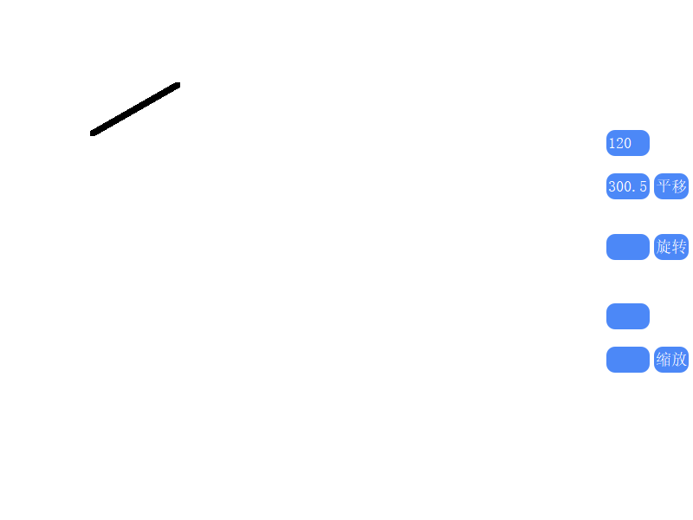
点击平移，图形平移，平移输入框清零
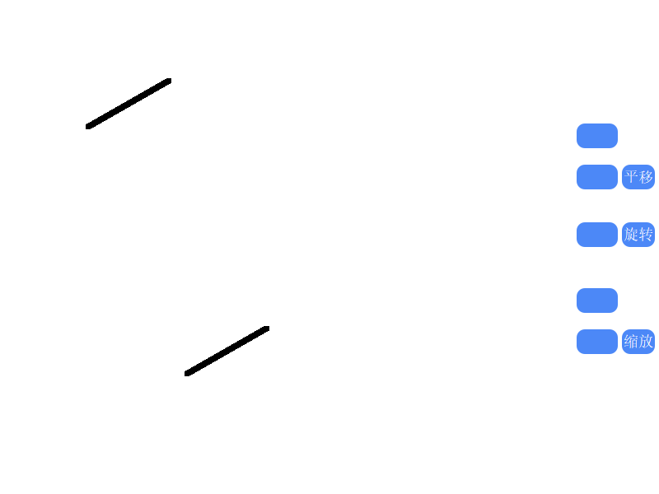
- 多边形

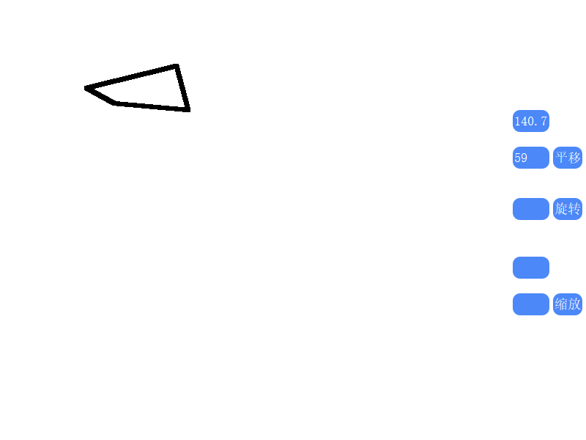
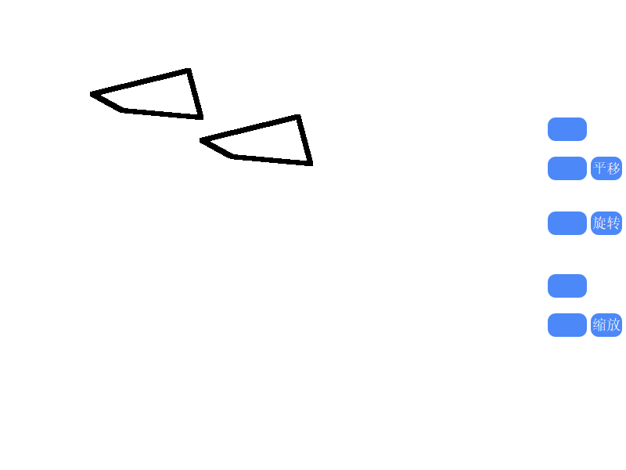

- 圆形
右键先后点击确定圆心和半径后画圆

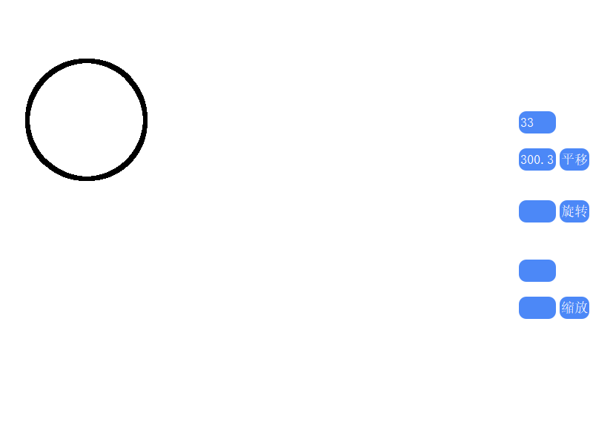
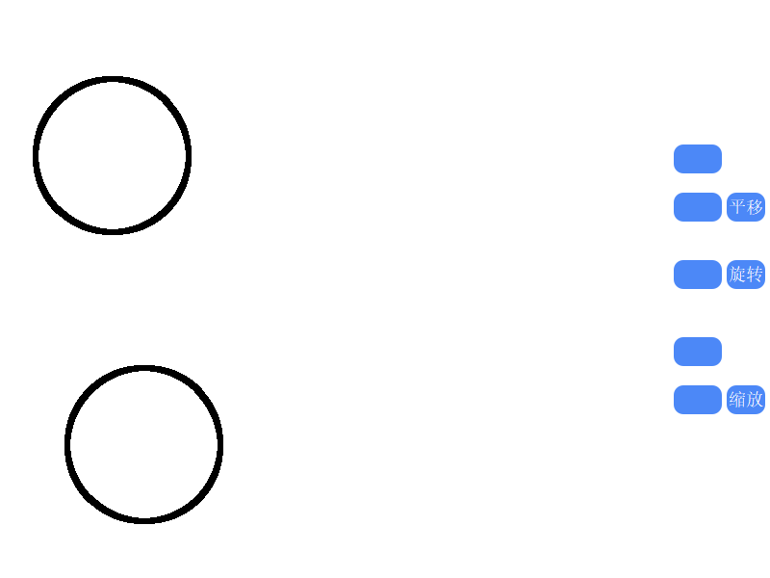

- 旋转
- 线段
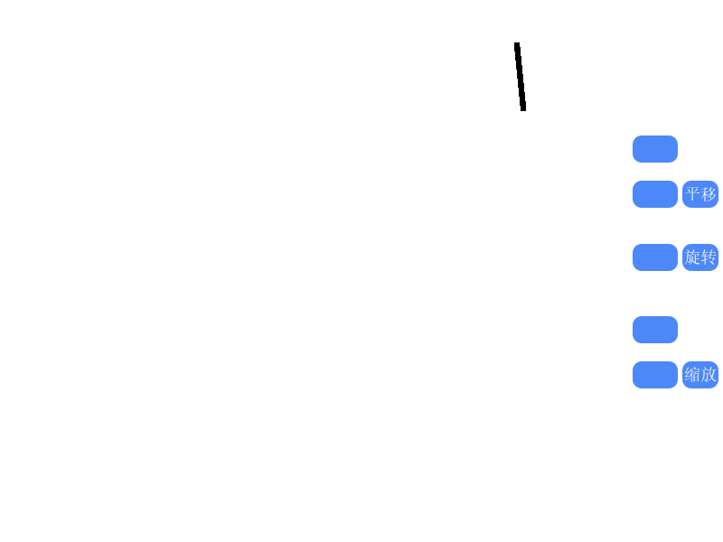
输入角度（整数），默认的旋转方向是顺时针
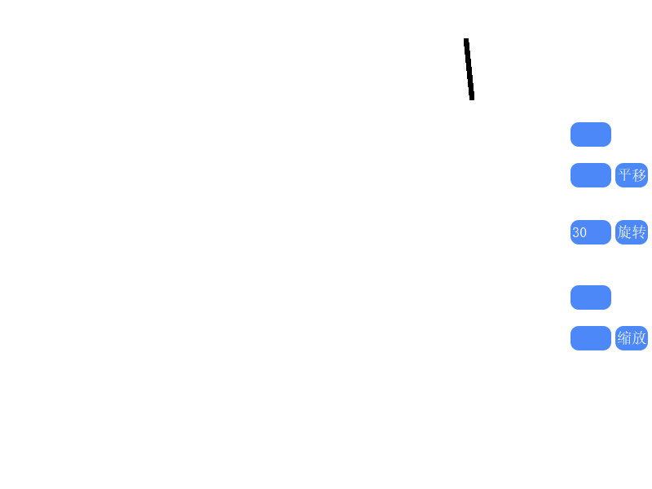
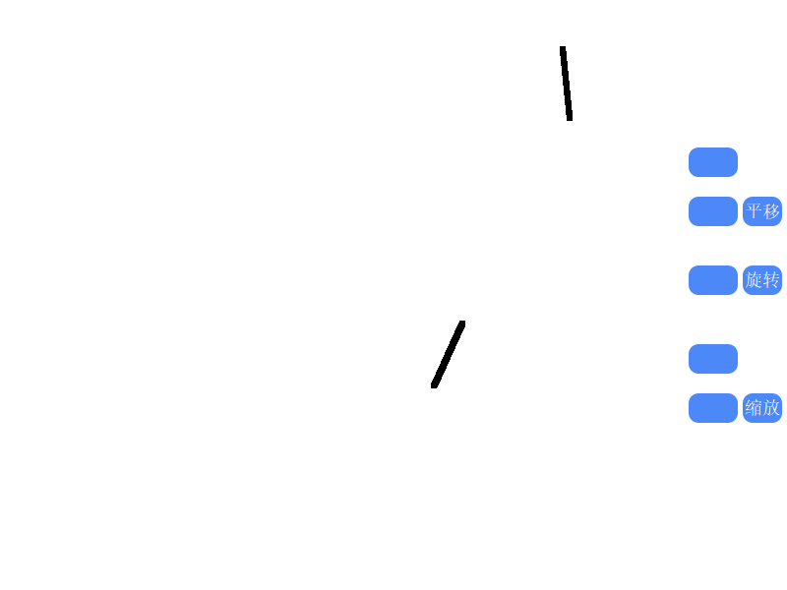
- 多边形

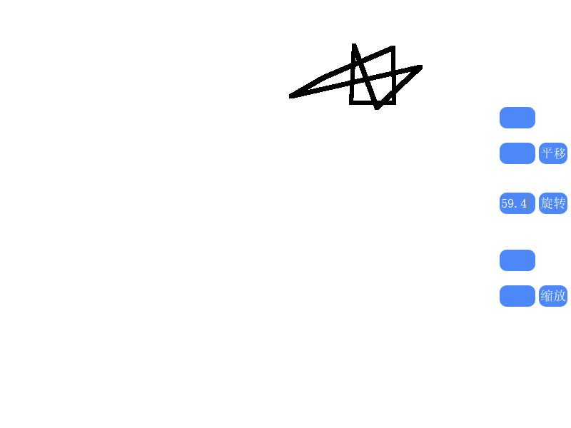
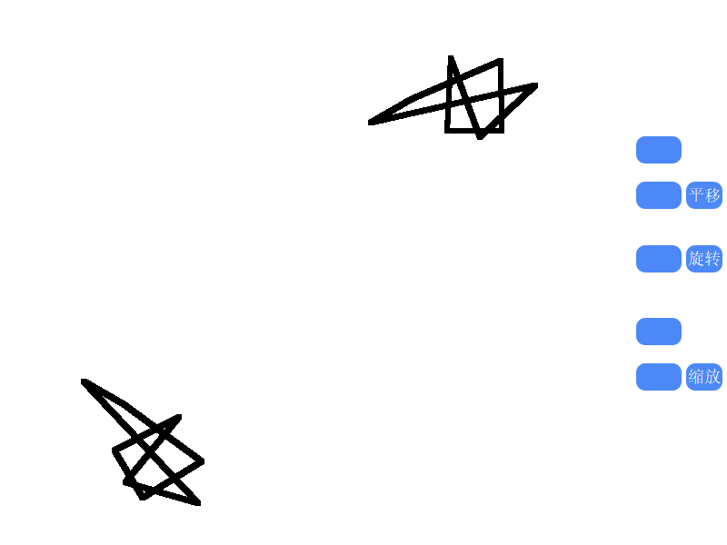
- 圆形

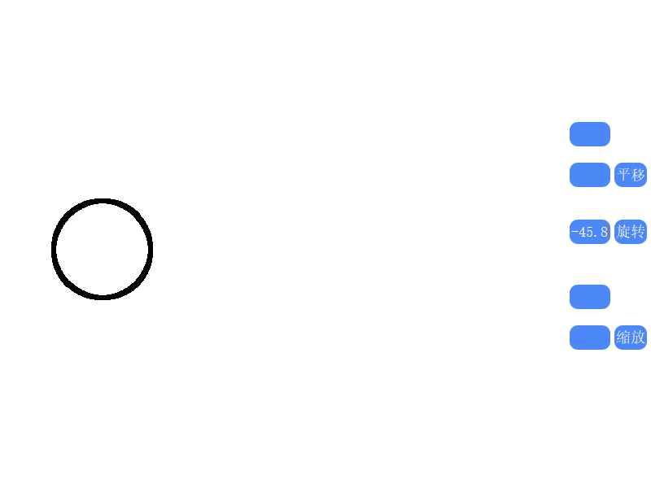
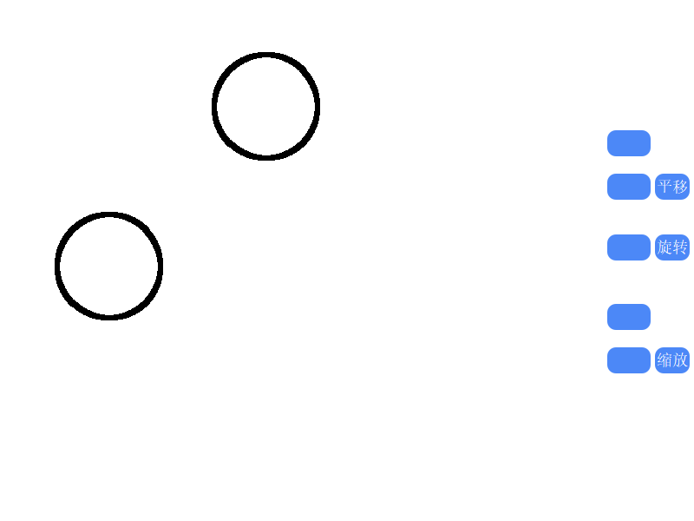

- 缩放
- 线段
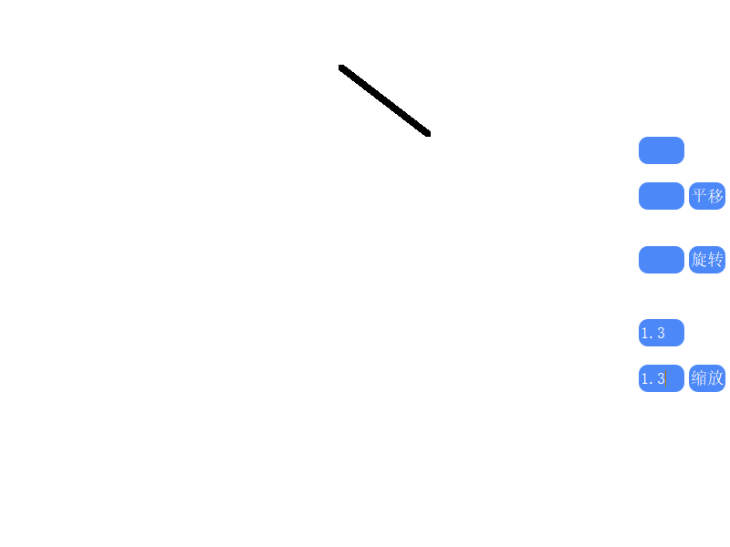
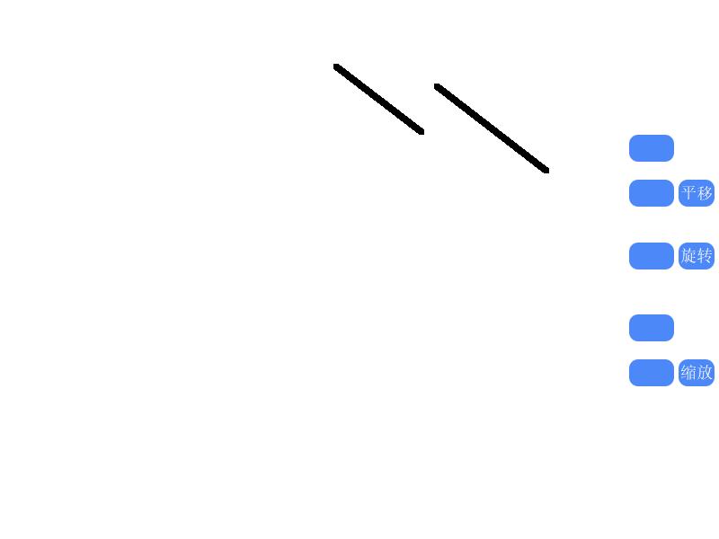
- 多边形
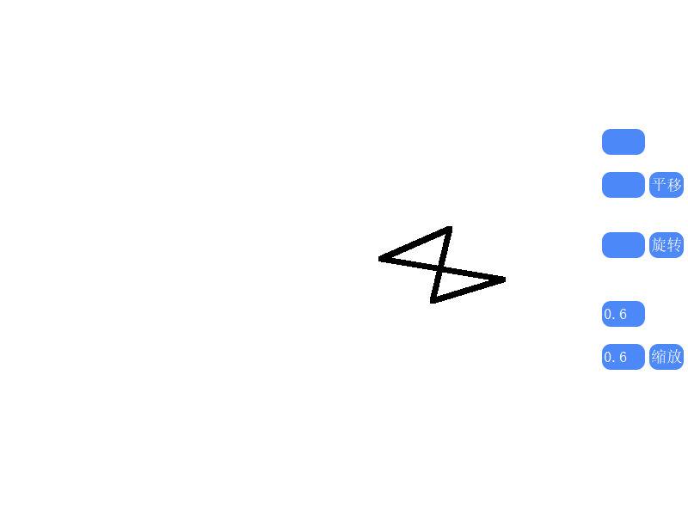
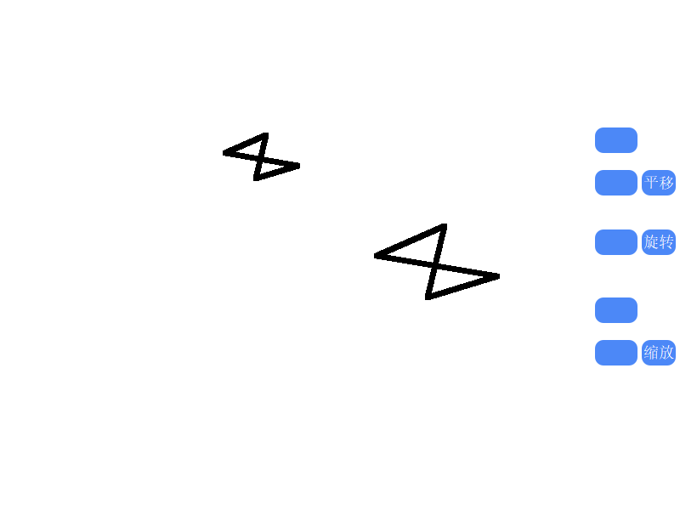
- 圆形
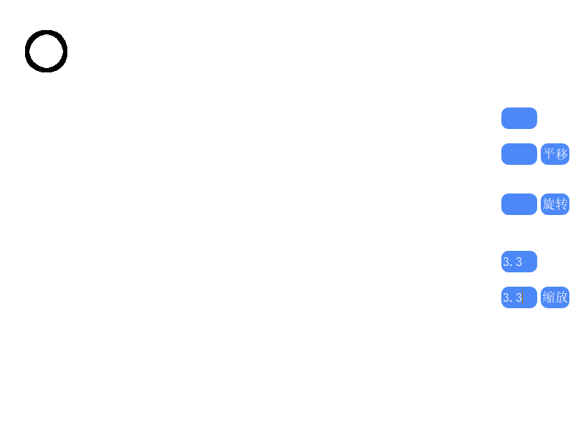
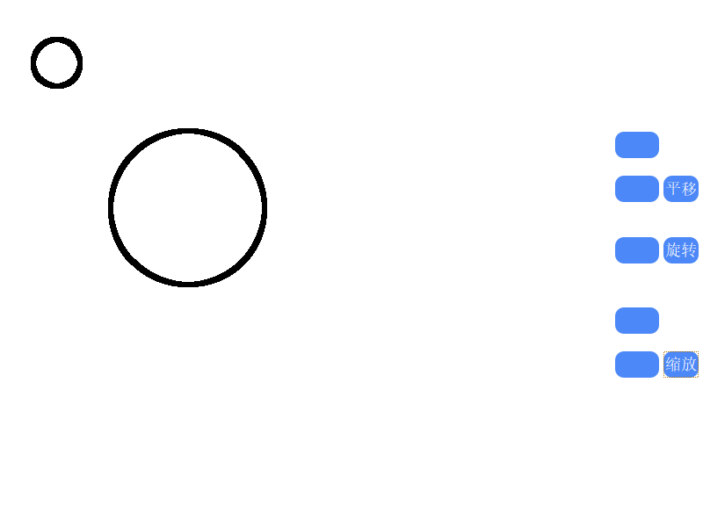

实验心得
这次的实验算是图形变换的一个基础，比较容易，就是根据不同的操作对于原图形的坐标进行不同的变换之后得到新图形，而这些变换的具体算式又较容易推导，所以整个实验做下来在算法层面没什么难度，但是涉及到了线段，圆形，多边形三种图形，综合了前几次实验，并且需要通过界面上的输入框去控制变换的具体值，即在输入框填写位移偏移量，旋转角度，缩放量，在界面设计上比较繁琐。比较遗憾的是，没有找到办法改变画板坐标的原点位置（默认的是左上角顶点为原点，所以旋转的角度受限）

